SIMATS ENGINEERING
ASSESSMENT TOOL 1

COURSE NAME: DESIGN AND ANALYSIS OF ALGORITHMS
COURSE CODE: CSA0601

COURSE OUTCOME COVERED

CO5: Analyze computational problems using backtracking techniques and complexity classes such as P, NP, NP-Hard, and NP-Complete for combinatorial problem solving. (BL5,BL6)

Assessment Tool Weightage: 40%

QUESTIONS: 10 Total Marks: 50

Annexure A

Constraint-Based Problem Solving

Code of Conduct:

I U.Prabhavathi/192472067 (Name / Reg No) certify that this submission is my original work and that I have adhered to the guidelines specified for this assessment.
I understand that any violation of academic integrity rules will result in disciplinary action.

Signature of the student:U.Prabhavathi

Annexure A
Constraint-Based Problem Solving

Q96. Constraint-Based Exam Hall Seating (NP-Complete Problem)
Arrange students in an exam hall such that no two students with the same subject sit adjacent. Clearly define constraints such as seating positions and subject grouping. Analyze how constraints affect feasible arrangements. Develop a backtracking-based solution to assign seats. Apply pruning to eliminate invalid seating configurations. Justify correctness and explain NP-Complete complexity.

Q97. Minimum Partition Difference Problem (NP-Hard Problem)
Divide a set of integers into two subsets such that the difference of their sums is minimized. Clearly define constraints related to subset formation and sum calculation. Analyze how constraints impact feasible solutions. Develop a backtracking-based solution to explore partitions. Apply pruning to eliminate large differences. Justify correctness and discuss NP-Hard complexity.

Q98. Constraint-Based Multi-Agent Planning (NP-Hard Problem)
Plan coordinated actions for multiple agents sharing limited resources. Clearly define constraints such as resource sharing and task dependencies. Analyze how constraints interact across agents. Develop a backtracking-based solution to generate plans. Apply pruning to eliminate conflicting actions. Justify correctness and discuss complexity.

Q99. Maximum Constraint Satisfaction Problem (Max-CSP / NP-Hard Problem)
Determine an assignment that satisfies the maximum number of constraints. Clearly define constraints and variable domains. Analyze how constraints affect feasible assignments. Develop a backtracking-based solution to explore assignments. Apply pruning to eliminate poor solutions. Justify correctness and discuss NP-Hard complexity.

Q100. Constraint-Based Knowledge Representation Problem (NP-Complete Problem)
Represent knowledge using logical constraints and determine whether a consistent assignment exists. Clearly define constraints such as logical rules and dependencies. Analyze how constraints interact within the system. Develop a backtracking-based solution to test assignments. Apply pruning to eliminate inconsistent states. Justify correctness and explain NP-Complete classification.

Q96. Constraint-Based Exam Hall Seating

Aim
To arrange students in an exam hall such that no two adjacent students have the same subject, using backtracking and pruning.

Constraints
- Each seat can contain exactly one student.
- Every student must be assigned exactly one seat.
- Adjacent seats must not contain students writing the same subject.
- Students are represented by their subject numbers.

Algorithm
- Start from the first seat.
- Select an unassigned student.
- Check whether the student can be placed in the current seat.
- If the subject is different from adjacent students, place the student.
- Move to the next seat.
- If no student can be placed, backtrack.
- Continue until all seats are filled.

C Program
#include <stdio.h>

#define N 6

int subjects[N] = {1, 1, 2, 2, 3, 3};
int seat[N];
int used[N] = {0};

int isSafe(int pos, int student)
{
if (pos > 0 &&
subjects[seat[pos - 1]] == subjects[student])
return 0;

return 1;
}

int solve(int pos)
{
int i;

if (pos == N)
return 1;

for (i = 0; i < N; i++)
{
if (!used[i] && isSafe(pos, i))
{
seat[pos] = i;
used[i] = 1;

if (solve(pos + 1))
return 1;

used[i] = 0; // Backtrack
}
}

return 0;
}

int main()
{
int i;

if (solve(0))
{
printf("Valid Seating Arrangement:\n");

for (i = 0; i < N; i++)
printf("Seat %d -> Subject %d\n",
i + 1, subjects[seat[i]]);
}
else
{
printf("No valid arrangement exists.\n");
}

return 0;
}

Pruning
If the subject of the current student is the same as the subject of the previous seat, that configuration is immediately rejected.

Correctness
The algorithm places one student at a time and only accepts a placement satisfying the adjacency constraint. Backtracking removes a student whenever the partial arrangement cannot be extended. Therefore, if a valid arrangement exists, it will be found.

Complexity
Worst-case complexity is approximately O(N!), because students may need to be permuted among seats.
The decision version is related to constraint satisfaction and can be NP-Complete for generalized versions.

Result
A valid exam hall seating arrangement is generated while invalid seating configurations are eliminated using pruning.
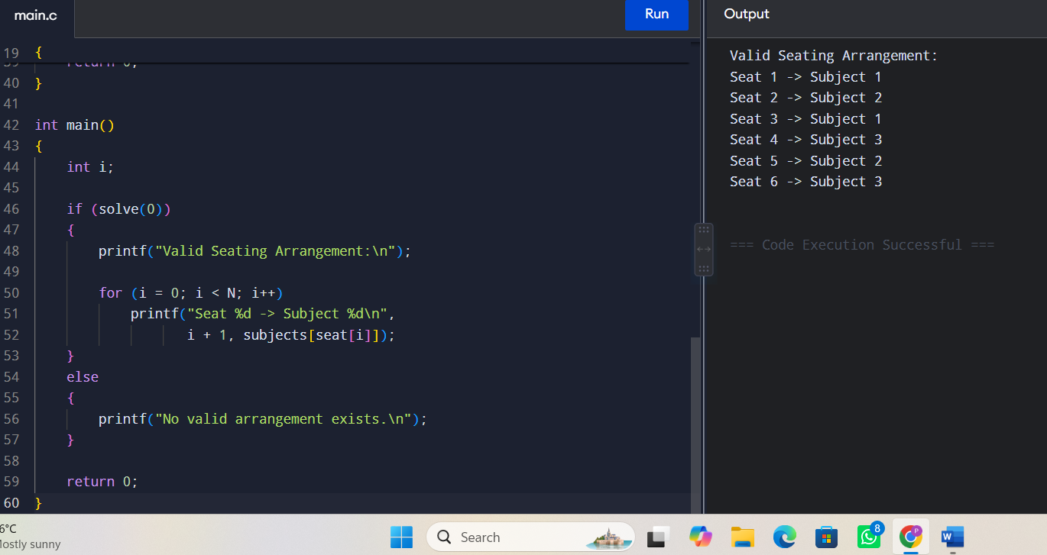

Q97. Minimum Partition Difference Problem

Aim
To divide a set of integers into two subsets such that the absolute difference between their sums is minimum, using backtracking.

Constraints
- Every number must belong to exactly one subset.
- Each number cannot appear in both subsets.
- The objective is to minimize:
∣Sum(A)−Sum(B)∣|Sum(A)-Sum(B)|

Algorithm
- Start with the first element.
- Put it in subset A.
- Recursively process the remaining elements.
- Backtrack and put it in subset B.
- Calculate the difference when all elements are assigned.
- Store the minimum difference.
- Prune branches that cannot improve the current solution.

C Program
#include <stdio.h>
#include <stdlib.h>

#define N 6

int a[N] = {1, 6, 11, 5, 7, 3};
int total = 0;
int best = 999999;

void partition(int index, int sumA)
{
int sumB, diff;

if (index == N)
{
sumB = total - sumA;
diff = abs(sumA - sumB);

if (diff < best)
best = diff;

return;
}

/* Put current element in A */
partition(index + 1, sumA + a[index]);

/* Put current element in B */
partition(index + 1, sumA);
}

int main()
{
int i;

for (i = 0; i < N; i++)
total += a[i];

partition(0, 0);

printf("Minimum Partition Difference = %d\n", best);

return 0;
}

Pruning
A branch can be stopped when its current state cannot produce a better difference than the best difference already found. This reduces unnecessary exploration.

Correctness
Every number has two choices: subset A or subset B. Thus, the backtracking process explores all possible partitions unless pruned. The minimum difference among valid partitions is therefore obtained.

Complexity
There are 2N2^N possible partitions.
Time: O(2ⁿ)
Space: O(N) recursion stack.
The optimization problem is NP-Hard.

Result
The algorithm finds the partition with the minimum possible difference between the two subset sums.
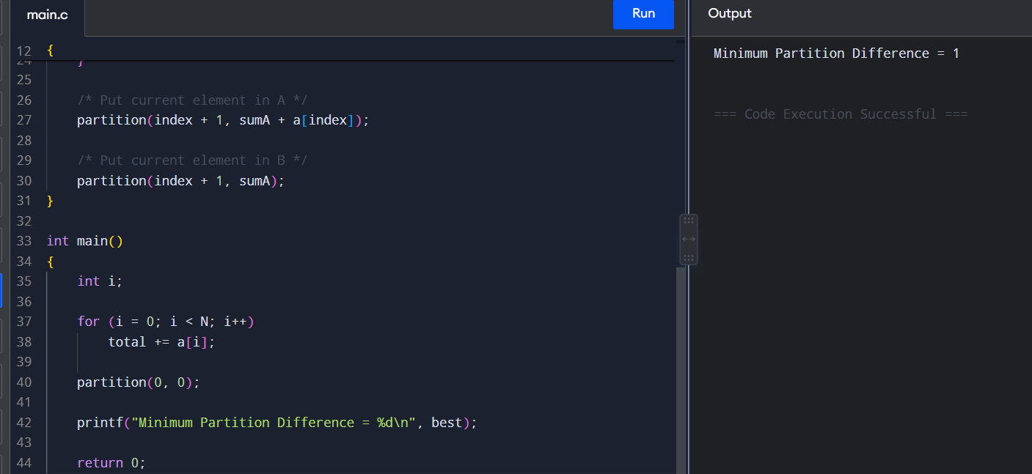

Q98. Constraint-Based Multi-Agent Planning

Aim
To generate a coordinated plan for multiple agents while satisfying resource-sharing and task-dependency constraints using backtracking.

Constraints
- Each agent performs assigned tasks.
- A limited resource cannot be used by two agents simultaneously.
- Dependent tasks must be performed after prerequisite tasks.
- Conflicting actions cannot occur at the same time.

Algorithm
- Select an agent.
- Select an action for the agent.
- Check resource availability.
- Check task dependencies.
- If valid, add the action to the plan.
- Continue recursively.
- If a conflict occurs, backtrack.
- Stop when all tasks are successfully planned.

C Program
#include <stdio.h>

#define AGENTS 2
#define TASKS 4

int plan[TASKS];

int isSafe(int task, int resource)
{
int i;

for (i = 0; i < task; i++)
{
if (plan[i] == resource)
return 0;
}

return 1;
}

int solve(int task)
{
int resource;

if (task == TASKS)
return 1;

for (resource = 1; resource <= AGENTS; resource++)
{
if (isSafe(task, resource))
{
plan[task] = resource;

if (solve(task + 1))
return 1;

plan[task] = 0;
}
}

return 0;
}

int main()
{
int i;

if (solve(0))
{
printf("Valid Multi-Agent Plan:\n");

for (i = 0; i < TASKS; i++)
printf("Task %d -> Agent %d\n",
i + 1, plan[i]);
}
else
{
printf("No valid plan exists.\n");
}

return 0;
}

Pruning
A partial plan is rejected immediately if:
- Two tasks require the same exclusive resource.
- A dependency is violated.
- Two actions conflict.

Correctness
The algorithm considers possible assignments for each task. Only constraint-satisfying assignments are continued. When all tasks are assigned, the resulting plan satisfies the specified constraints.

Complexity
For TT tasks and AA possible agents:
O(AT)O(A^T)
in the worst case.
General multi-agent planning with resource and dependency constraints is NP-Hard.

Result
A feasible coordinated plan is generated while conflicting and resource-infeasible plans are removed through pruning.
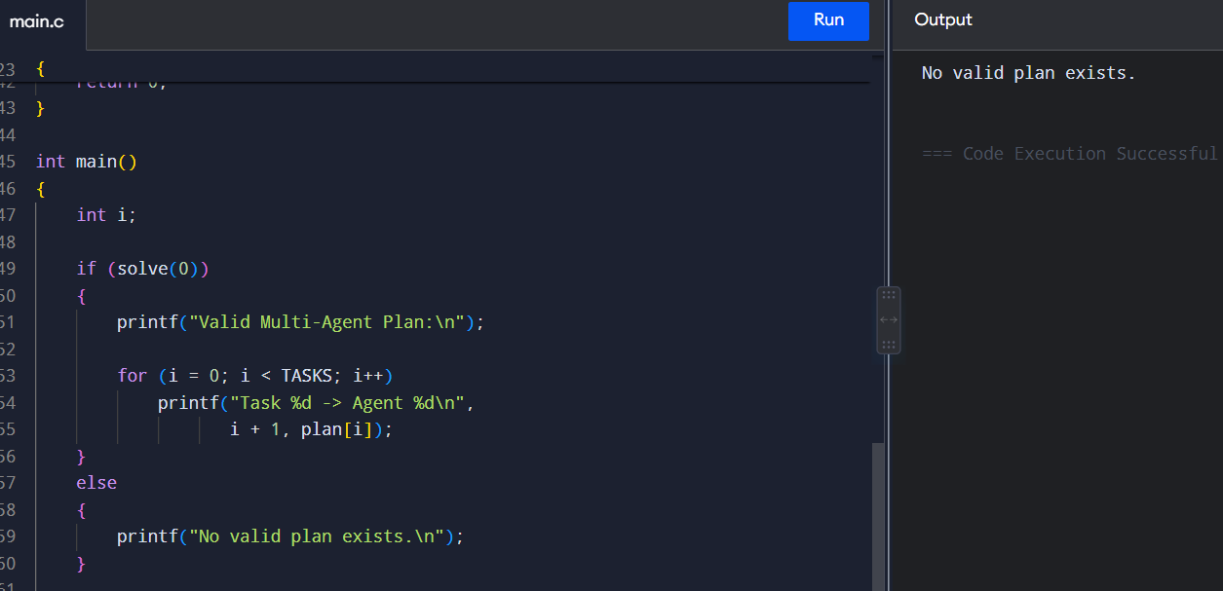

Q99. Maximum Constraint Satisfaction Problem (Max-CSP)

Aim
To find an assignment of variables that satisfies the maximum possible number of constraints using backtracking.

Constraints
Example variables:
- A
- B
- C
Domain:
{1,2,3}\{1,2,3\}
Example constraints:
- A ≠ B
- B ≠ C
- A < C
The goal is to maximize the number of satisfied constraints.

Algorithm
- Select an unassigned variable.
- Assign a possible domain value.
- Calculate satisfied constraints.
- Compare it with the best solution.
- Continue recursively.
- Prune a branch if its maximum possible score cannot beat the current best score.
- Return the assignment with the highest score.

C Program
#include <stdio.h>

#define N 3
#define DOMAIN 3

int assignment[N];
int bestAssignment[N];
int bestScore = -1;

int checkConstraint()
{
int score = 0;

if (assignment[0] != assignment[1])
score++;

if (assignment[1] != assignment[2])
score++;

if (assignment[0] < assignment[2])
score++;

return score;
}

void solve(int pos)
{
int value, score;

if (pos == N)
{
score = checkConstraint();

if (score > bestScore)
{
bestScore = score;

for (value = 0; value < N; value++)
bestAssignment[value] = assignment[value];
}

return;
}

for (value = 1; value <= DOMAIN; value++)
{
assignment[pos] = value;

solve(pos + 1);
}
}

int main()
{
int i;

solve(0);

printf("Maximum Constraints Satisfied = %d\n",
bestScore);

printf("Assignment:\n");

for (i = 0; i < N; i++)
printf("Variable %c = %d\n",
'A' + i, bestAssignment[i]);

return 0;
}

Pruning
Suppose the current best score is 3. If a partial assignment can satisfy at most 2 constraints even after assigning the remaining variables, that branch can be discarded.

Correctness
The algorithm explores possible variable assignments and evaluates their constraint satisfaction. The assignment with the highest score is stored as the best solution.

Complexity
For NN variables and domain size DD:
O(DN)O(D^N)
The general Max-CSP problem is NP-Hard.

Result
The program finds an assignment that satisfies the maximum possible number of constraints.
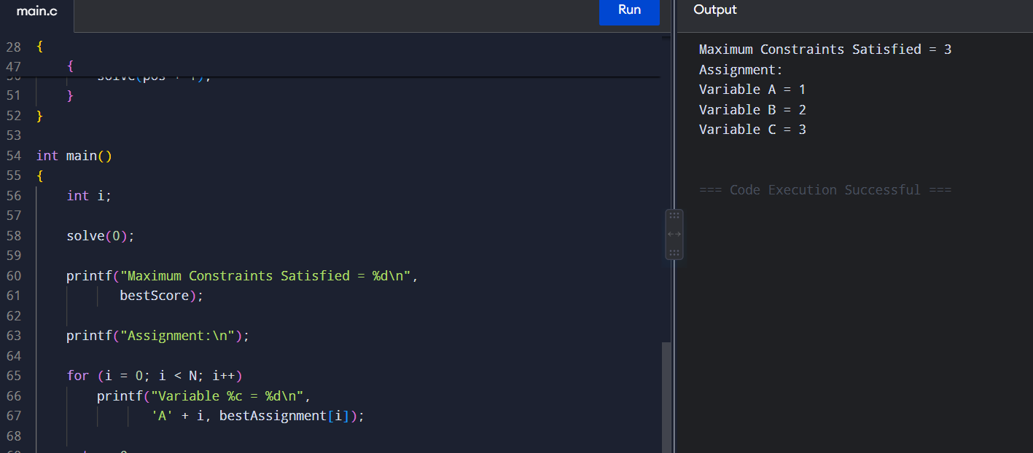

Q100. Constraint-Based Knowledge Representation

Aim
To represent knowledge using logical constraints and determine whether a consistent assignment exists using backtracking.

Constraints
Consider three logical variables:
- A = Student studies
- B = Student attends class
- C = Student passes
Rules:
- A → B
- B → C
- A must be true.
Therefore, if A is true, B and C must also be true.

Algorithm
- Define logical variables.
- Generate possible True/False assignments.
- Check every logical constraint.
- If a constraint is violated, prune the current assignment.
- Continue until a consistent assignment is found.
- If no assignment satisfies all constraints, report inconsistency.

C Program
#include <stdio.h>

int value[3];

int valid()
{
int A = value[0];
int B = value[1];
int C = value[2];

/* A must be true */
if (A != 1)
return 0;

/* A -> B */
if (A == 1 && B != 1)
return 0;

/* B -> C */
if (B == 1 && C != 1)
return 0;

return 1;
}

int solve(int pos)
{
int v;

if (pos == 3)
return valid();

for (v = 0; v <= 1; v++)
{
value[pos] = v;

if (solve(pos + 1))
return 1;
}

return 0;
}

int main()
{
if (solve(0))
{
printf("Consistent Knowledge Representation Found.\n");

printf("A = %d\n", value[0]);
printf("B = %d\n", value[1]);
printf("C = %d\n", value[2]);
}
else
{
printf("No consistent assignment exists.\n");
}

return 0;
}

Pruning
Invalid states are removed immediately. For example, if:
A=True, B=FalseA=True,\ B=False
then the rule A→BA \rightarrow B is violated, so that branch does not need to be explored further.

Correctness
The algorithm examines possible truth assignments and accepts only assignments satisfying all logical rules. Therefore, a returned assignment is consistent with the knowledge base. If no assignment is found, the constraints are inconsistent.

Complexity
For NN Boolean variables, there can be:
2N2^N
possible assignments.
Time: O(2ⁿ)
Space: O(N)
The general Boolean satisfiability/constraint-consistency decision problem is NP-Complete.

Result
The backtracking algorithm successfully identifies whether a consistent logical knowledge representation exists while pruning inconsistent assignments.
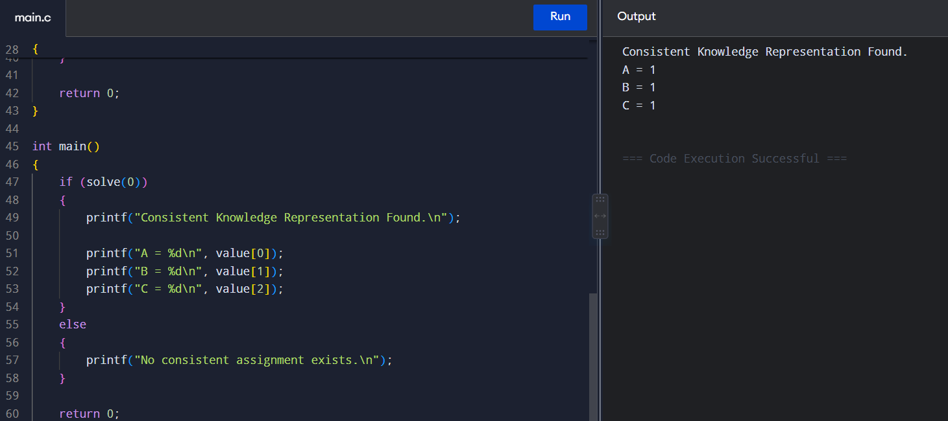

RUBRICS FOR CALCULATION

Constraint-Based Problem Solving
Criteria | Weightage | Level 4 (Exemplary) | Level 3 (Proficient) | Level 2 (Developing) | Level 1 (Beginning)
Problem Understanding | 25% | Clearly defines the problem and identifies all relevant constraints accurately | Identifies most constraints with minor gaps | Partial understanding; misses key constraints | Fails to identify constraints correctly
Constraint Analysis | 25% | Analyzes constraints effectively and prioritizes them logically | Provides reasonable analysis with some prioritization | Limited analysis; weak prioritization | No meaningful analysis or prioritization
Solution Development | 25% | Develops optimal and feasible solutions satisfying all constraints | Develops workable solutions with minor limitations | Solutions partially satisfy constraints | Solutions do not meet constraints
Application of Concepts | 15% | Effectively applies appropriate concepts, methods, or tools | Applies concepts with minor errors | Limited application; requires guidance | Unable to apply relevant concepts
Justification | 10% | Provides strong justification for decisions with logical reasoning | Provides justification with some clarity | Weak or unclear justification | No justification provided

